1. Login to Salesforce
- Go to:
👉 https://login.salesforce.com (for production)
👉 https://test.salesforce.com (for sandbox)
- Enter:
  - Username
  - Password
- Click Login

2. Open Developer Console
After login:
- Click on ⚙️ (Gear icon) in top-right
- Click Developer Console
👉 A new window will open (this is where you write Apex code)

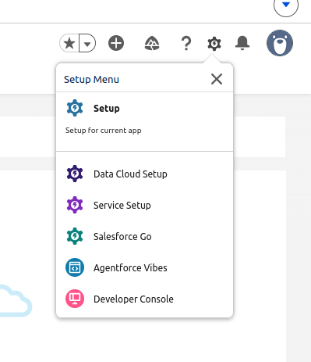

3. Create Apex Class (Calculator)
- In Developer Console:
  - Click File → New → Apex Class
- Enter name:

Calculator

- Paste your code:

public class Calculator {
public Double num1 { get; set; }
public Double num2 { get; set; }
public Double result { get; set; }

// Standard Math
public void doAdd() { result = num1 + num2; }
public void doSubtract() { result = num1 - num2; }
public void doMultiply() { result = num1 * num2; }
public void doDivide() {
result = (num2 != 0) ? num1 / num2 : null;
}

// Scientific Math
public void doLog() {
if(num1 > 0) result = Math.log10(num1);
}

public void doSin() {
// Converts Degrees to Radians
result = Math.sin(num1 * Math.PI / 180);
}

public void doCos() {
result = Math.cos(num1 * Math.PI / 180);
}

public void doTan() {
result = Math.tan(num1 * Math.PI / 180);
}
}

- Click Save (Ctrl + S)

4. Create Visualforce Page (UI)
- In Developer Console:
  - Click File → New → Visualforce Page
- Enter name:

CalculatorUI

- Paste this code:

<apex:page controller="Calculator">
<apex:form>
<apex:pageBlock title="Scientific Calculator">

<apex:pageBlockSection columns="1">
<apex:inputText value="{!num1}" label="Number 1 (or Degrees)"/>
<apex:inputText value="{!num2}" label="Number 2 (for basic ops)"/>
</apex:pageBlockSection>

<apex:pageBlockSection title="Basic Operations" columns="4">
<apex:commandButton value="+" action="{!doAdd}" rerender="res" style="width:60px; background:#f8f9fa;"/>
<apex:commandButton value="-" action="{!doSubtract}" rerender="res" style="width:60px; background:#f8f9fa;"/>
<apex:commandButton value="×" action="{!doMultiply}" rerender="res" style="width:60px; background:#f8f9fa;"/>
<apex:commandButton value="÷" action="{!doDivide}" rerender="res" style="width:60px; background:#f8f9fa;"/>
</apex:pageBlockSection>

<apex:pageBlockSection title="Scientific (Uses Number 1)" columns="4">
<apex:commandButton value="SIN" action="{!doSin}" rerender="res" style="background:#e3f2fd; color:#0d47a1;"/>
<apex:commandButton value="COS" action="{!doCos}" rerender="res" style="background:#e3f2fd; color:#0d47a1;"/>
<apex:commandButton value="TAN" action="{!doTan}" rerender="res" style="background:#e3f2fd; color:#0d47a1;"/>
<apex:commandButton value="LOG10" action="{!doLog}" rerender="res" style="background:#fff3e0; color:#e65100;"/>
</apex:pageBlockSection>

<apex:outputPanel id="res">
<apex:pageBlockSection rendered="{!NOT(ISNULL(result))}">
<div style="font-size:1.5em; padding:10px; background:#f1f8e9; border-left:5px solid #4caf50;">
<b>Result:</b> {!result}
</div>
</apex:pageBlockSection>
</apex:outputPanel>

</apex:pageBlock>
</apex:form>
</apex:page>

- Click Save
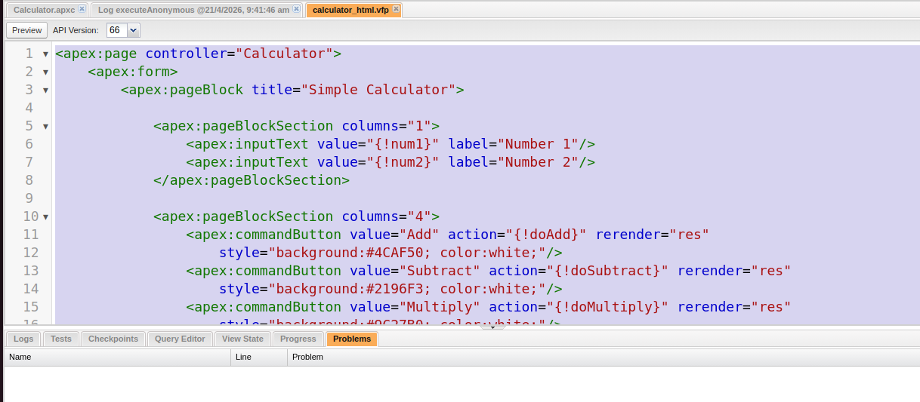

5. Run the Page
- Click Preview (top toolbar in Developer Console)
OR
- Open in browser:

https://yourInstance.salesforce.com/apex/CalculatorUI

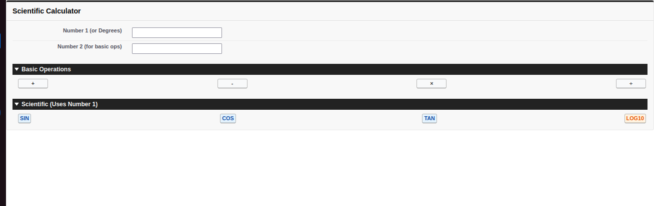

6. How It Works (Short Explanation)
- User enters num1 and num2
- Button click sets operation (add, sub, etc.)
- calculate() method runs
- Result is displayed on UI

